Rhoda Woets

E. r.woets@vu.nl

Word count, including references: 503

Antubam, Kofi

Kofi Antubam (1922-1964) was one of the most influential pioneering modern artists in Ghana. His realistic, narrative scenes in wall paintings and mosaics of an idealized African life have influenced a great number of artists after him. Antubam was appointed as an official state artist after Ghana’s independence in 1957. This was not surprising as Antubam was firmly convinced that artists should contribute to national pride and development and present Ghana in their art work as a modern nation with a unique past and culture. Antubam received his art education at Achimota School in Accra, and Goldsmith College in London. He exhibited his work in Ghana and in cities such as London, Paris, Rome and Düsseldorf as well as in New York. Antubam challenged contemporary artists to use the skills of their European based art training as a tool in painting cultural portraits of African ‘traditional’ culture. A representational art style, he argued, was only a vehicle to express what lay within, and this shows how modern and progressive the artist was. Assimilation was the key-word for Antubam in the development of a national and African identity that –despite the assimilation of foreign elements- he argued, would remain distinct from East and West.

Already during his school days in Achimota Kofi Antubam painted cultural scenes on the college walls. Many murals and paintings would follow and most of them were romanticized scenes of everyday (village) life or royal depictions of chiefs with their linguists. Artistically, Antubam was inspired by traditional institutions of royalty and concepts of beauty: oval shaped heads, majestic repose, and rounded figures. Antubam’s paintings of prosperous, culturally rich villages, are seemingly undisturbed by colonial encounters, or by the first president Kwame Nkrumah’s modernisation projects.

Antubam was one of the first artists to introduce adinkra symbols in the fine arts which he used in the commissioned works of the new government in power in the early sixties. Adinkra are a set of local symbols that are imprinted on cotton cloth and mostly worn at funerals. Antubam used adinkra symbols in, amongst others, the panelled doors of the legislative assembly in Accra and three chairs for state ceremonies (Fig. 2). Adinkra symbols apply in all these nationalistic objects as decorative designs representing Kwame Nkrumah’s national and Pan-African ideals.

Antubam died of a stroke at the age of 42 and was granted a state burial.

References and further reading

Antubam, K. (1963), Ghana’s Heritage of Culture Leipzig: Koehler & Amelang.

Bedu-Addo, A. (1977), ‘Kofi Antubam. His life and work’ In: Sankofa Arts and Culture Magazine, p.16-20 Accra: Arts Council of Ghana.

Fosu, K. (1993), 20th Century Art of Africa (revised edition). Kumasi: Design press, University of Science and Technology.

Mount, M. W. (1973), African Art. The Years Since 1920. Devon: Davis & Charles Holdings limited.

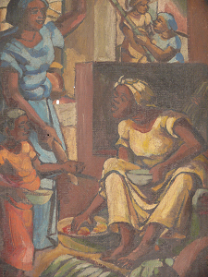

1. Kofi Antubam, How Much (detail), oil on board, 1954.
Collection: National Museum in Accra/ Ghana Museums and Monuments Board Ghana. Photograph taken by author.

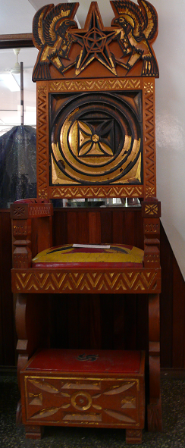
2. Kofi Antubam, Chair of State, 1960.
Collection: National Museum in Accra/ Ghana Museums and Monuments Board Ghana. Photograph taken by author.

